Analytical Question
To what extent does national wealth lead to equitable human development, and where does economic growth fail to reduce gender inequality?

Chart 1: GDP vs Gender Development Index (GDI) – Tableau

This visualization examines whether higher national income is associated with greater gender equality in development outcomes. Specifically, it explores whether economic growth contributes to closing gender gaps in education, health, and income, as measured by the Gender Development Index (GDI).

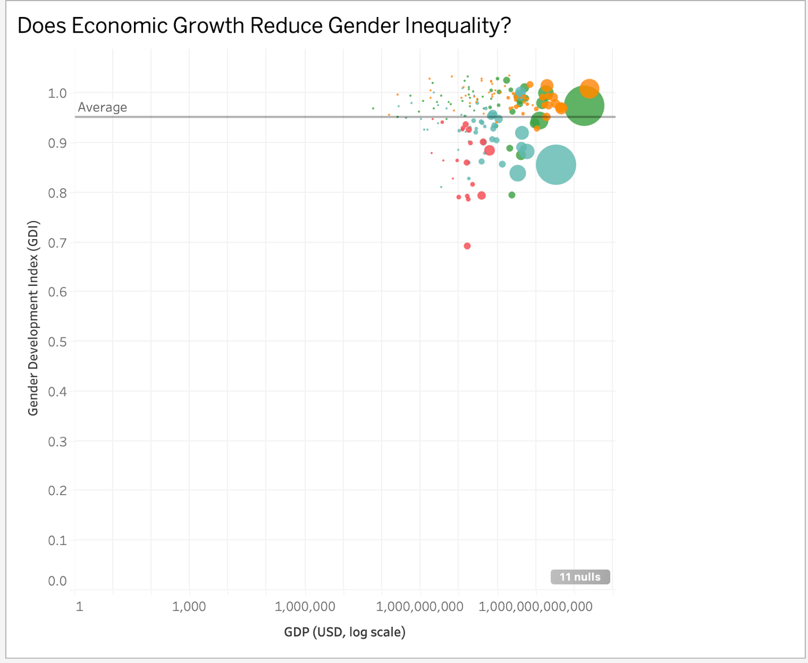
What the Chart Shows
The scatterplot displays countries based on their GDP (log scale) and GDI values, with color representing income group and size representing population. Size encodes total population, revealing that demographic scale does not guarantee gender equality outcomes. The chart shows a generally positive relationship between GDP and GDI, where higher-income countries tend to cluster near gender parity (GDI ≈ 1). However, there is still noticeable variation within income groups, particularly among lower and middle-income countries, where several countries fall below the global average. Larger population countries also exhibit mixed outcomes, indicating that national scale does not guarantee gender equality.
Key Insight / Interpretation
The visualization suggests that while economic growth is associated with improvements in gender equality, it does not fully eliminate disparities. Even among wealthier nations, gender equality outcomes are not uniform. This indicates that structural, cultural, and policy factors beyond income play a significant role in shaping gender development. Therefore, economic growth alone is insufficient to fully close gender gaps in education and opportunity.

Chart 2 : Gender Equality Trends Over Time by Region (Tableau)

This chart analyzes how gender equality, measured by the Gender Development Index (GDI), has changed over time across global regions. It helps assess whether progress in development has been consistent and whether gender gaps are narrowing across regions.
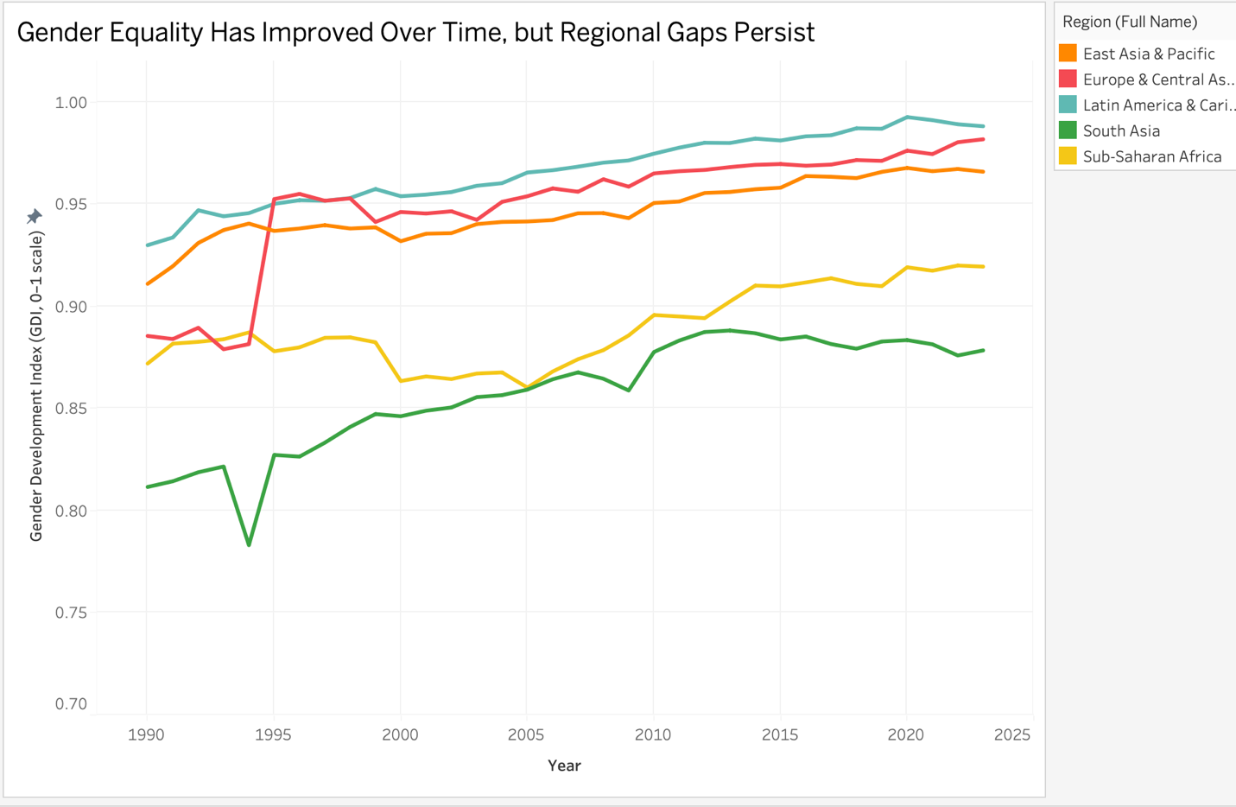

What the Chart Shows
All regions show a gradual improvement in GDI from 1990 to recent years, indicating overall global progress in gender equality. However, clear regional differences remain. Europe & Central Asia and Latin America & Caribbean maintain the highest GDI levels throughout the period, approaching parity. In contrast, South Asia and Sub-Saharan Africa start at lower levels and, despite improvement, continue to lag behind other regions.
Key Insight
Although gender equality has improved over time, progress is uneven across regions. Higher-performing regions sustain near-equal development outcomes, while lower-performing regions improve more slowly and do not fully close the gap. This suggests that while development contributes to gender equality, regional and structural factors continue to limit convergence.
Connection to Overall Analysis
This chart complements the GDP vs GDI analysis by adding a time dimension. While higher income is associated with better gender development, this visualization shows that growth alone does not eliminate disparities. Regional differences persist even as all regions improve, highlighting that economic growth is necessary but not sufficient to fully close gender gaps.

Chart 3: Gender Equality Varies Within Income Groups (Python)
This visualization examines whether countries with similar income levels achieve similar gender equality outcomes, assessing whether economic wealth alone determines gender development.

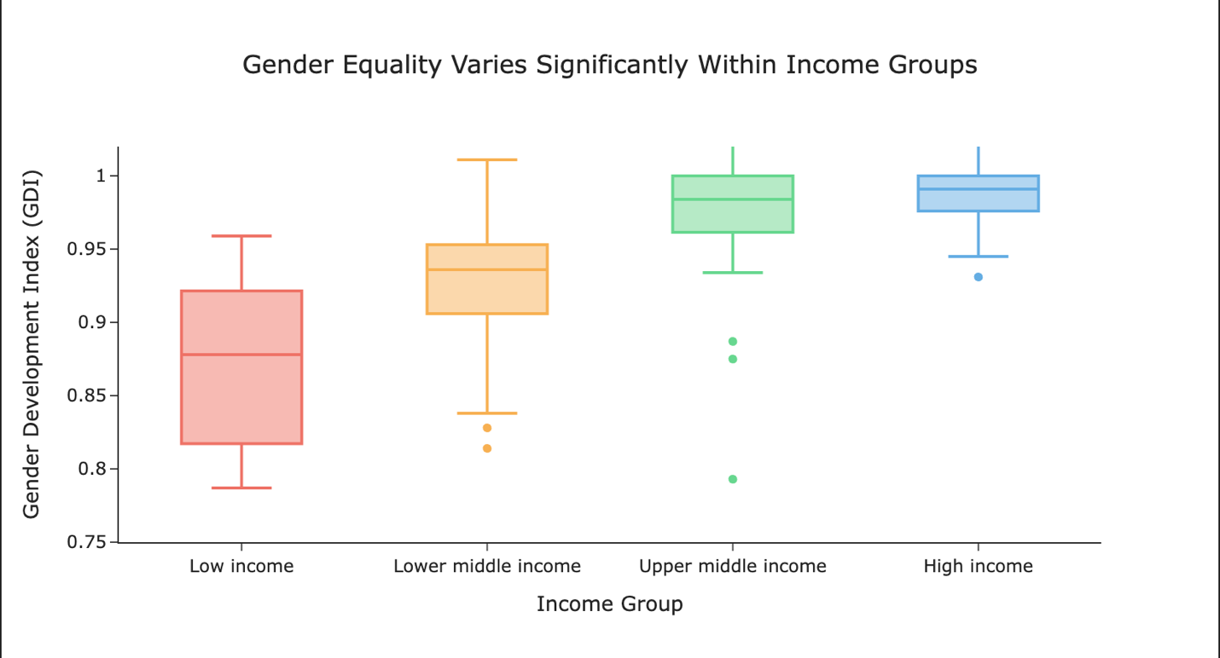

What the Chart Shows:
The box plot shows that while higher-income countries generally have higher Gender Development Index (GDI) values, there is noticeable variation within each income group. Lower- and middle-income groups display a wider spread, indicating more inconsistent outcomes. In some cases, lower-income countries approach GDI levels seen in wealthier nations, while others lag significantly behind.
Key Insight:
The variation within income groups indicates that economic growth alone does not ensure gender equality. Differences in institutions, policies, and social conditions likely play a critical role in shaping gender development outcomes.

Chart 4: Progress in Gender Equality Differs Across Income Groups (Python)
This chart evaluates how gender equality has evolved over time across different income levels, assessing whether economic growth leads to convergence in gender development.
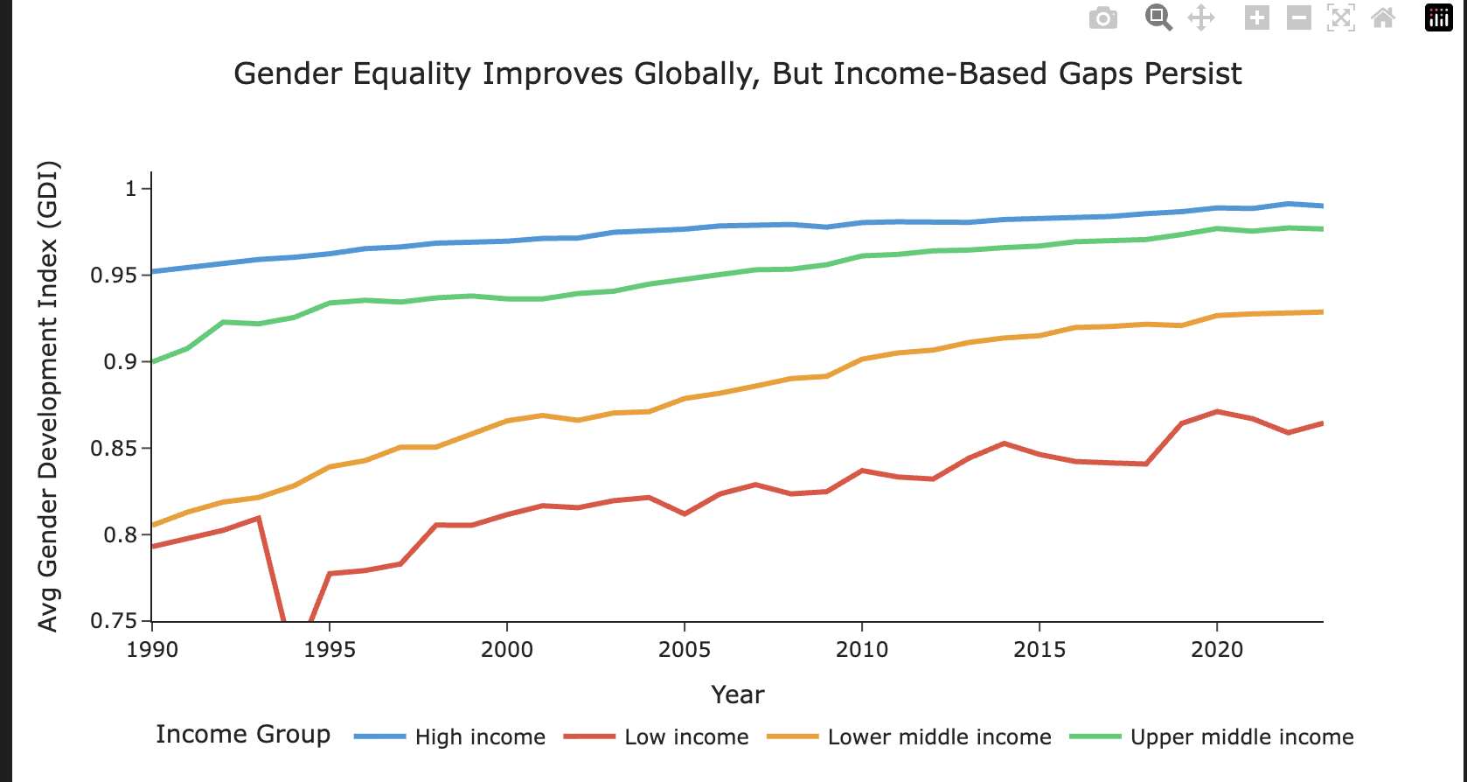
What the Chart Shows:
All income groups show improvement in GDI over time, indicating global progress. However, high-income countries start at higher levels and maintain their advantage, while lower-income countries improve more slowly and remain below higher-income groups.
Key Insight:
Although economic growth improves gender equality outcome but does not lead to convergence across income groups. Persistent gaps across income groups highlight uneven progress and suggest that growth alone is insufficient to achieve equal outcomes.

CONCLUSION
Together, these findings show that while income is an important driver of gender development, it is not sufficient on its own, and targeted policies are required to achieve equitable outcomes.

